Linear/Matrix Algebra

Planar Antenna Array for the MQ-9 Predator Unmanned Aerial Vehicle (UAV)

Author: Team MCCCXXXVII

Team: MCCCXXXVII

Team Leader: Michael P. Doran

Team Members:

Carlos J. Lazo

Carolyn M. Andrews

Colin D. Fischer

Michael P. Doran

Course: Linear Matrix Algebra

Instructor: Duane A. Beaulieu

Group Hours: 42

Date Submitted: 10/6/2008

Executive Summary

Problem

Experts in the field of Electronic Warfare (EW) have identified a new radio that hostile forces are using in the battlefield. There is an urgent need to jam all communications from this radio in order to hinder enemy advancement and all crucial transmissions. BAE Systems is looking to initiate a high priority operation to develop a System of Airborne Neutralization Tactical Antennas (SANTA) to address the situation.

In order to jam the radio signal, our high performance Integrated Project Team (IPT), Team MCCCXXXVII, has been asked to design a planar antenna array composed of Commercial Off The Shelf (COTS) antennas and High Power Amplifiers (HPAs). This antenna array will be mounted on an MQ-9 Predator Unmanned Aerial Vehicle (UAV) and will overpower the enemy radio, preventing all hostile receivers from acquiring the signal.

The jamming beam must remain on the target for up to 20 minutes to support ground countermeasures being planned by allied forces. SANTA mission planners have mapped out the Predator’s flight path to within 5 nautical miles of the stationary target.

Method of Analysis

In order to develop a feasible solution given the threat at hand, our group builds the planar array based on realistic electrical and mechanical constraints.

Our group first determines the transmit signal power required to jam the hostile radio signals. We consider the worst case scenario in the link budget power analysis, occurring when the UAV is furthest away from the target. Based on this distance, signal attenuation through the atmosphere, and the power required to jam a receiver, we successfully derive the amount of power we must transmit through our array. We also determine the beam width necessary to cover the 10 nautical mile target zone from our UAV’s altitude. This provides us the knowledge required to determine the overall dimensions of our antenna array.

The mathematical analysis allows our group to conduct a commercial trade study. We pick COTS components that cater to our derived system requirements. We consider size, weight, and power consumption, as our designs are constrained by the limits of the Predator UAV. We perform all mathematical analysis using MATLAB and mechanical design using Pro-E.

Results / Recommendations

We have determined that the planar antenna array described in our results section will meet or exceed all requirements for this mission. The design stays well within electrical requirements while maintaining a conservative yet effective mechanical design. Our team recommends that the antenna array be developed immediately so that efforts encompassing the SANTA initiative can be executed safely and successfully.

Table of Contents

Executive Summary 2
Problem 2
Method of Analysis 2
Results / Recommendations 2
Problem Statement 5
Overview 5
System Description 5
Assumptions 6
System Analysis 8
Approach 8
Detailed Analysis 8
Electrical Analysis 8
Mechanical Analysis 11
Results 13
Results 13
Recommandations 14
References 15
Appendix 16
Appendix A – Performance Plots 16
Appendix B – Electrical/Mechanical Analysis 20
Antenna Assembly Weights 20
Antenna Assembly Power Consumption 20
Mechanical Assembly 20
Structural Substantiation of Antenna Assembly 24
Stress Analysis on Antenna Assembly Cover 25
Mechanical Statistics and Tables 26
Geometry 26
Mesh 27
Static Structural 28
Solution 30
Material Data 31
Aluminum Alloy 31
Appendix C – MATLAB Code 35
Appendix D – Trade Study 41

List of Tables

Table (1) - Antenna Beam Pattern Cases 10

Nomenclature

Symbol | Definition | Units
f | Frequency | GHz
λ | Wavelength | Meters (m)
D | Length of Antenna Array | m
d_{x}, d_{y} | Distance between antenna elements in a given direction | m
n_{x}, n_{y} | Number of antenna elements in a given direction | ----
R_{bw}, R_{i} | Radial Distance | m
c | Speed of light | Meters/Second (m/s)

Problem Statement

Overview

The Electronic Warfare division of BAE Systems was informed that a group of insurgents are using a new method of radio communication. Given the uncertainty surrounding this new situation, we as a company cannot afford to let these transmissions continue. BAE Systems feels that the best course of action is to jam these communications as soon as possible, allowing for the creation of a long-term strategic countermeasure to be developed.

Our IPT group has been assigned the critical task of creating a planar antenna array that will effectively overpower the receivers awaiting the transmission from this stationary enemy radio. As a multidisciplinary team, we perform an electrical analysis of the problem, looking at power requirements needed given our flight trajectory along with COTS elements that can satisfy our needs. Coupled with the power analysis, we examine the mechanical structure of the MQ-9 to ensure that we can safely mount our antennas together in a viable manner on the UAV.

Our group works through antenna calculations using a link budget analysis to derive the amount of power needed to be output by the planar array. We test waveforms through the MATLAB programming interface, ensuring that the beam patterns match what we would expect to see. Instead of moving the mechanical fixture as the UAV flies its path, we adjust the steering angle, or phase, of all the antenna components at the same time. Using this steering angle, we can concentrate our jamming beam on the target during the required 20 minute period.

From a mechanical standpoint, we developed fixtures to mount the antenna array under one of the wings of the MQ-9. We use the Pro-E modeling package to generate 3-D models of the UAV and antenna array, along with Mathcad 14.0 and the ANSYS Workbench for stress analysis of our system. Images of the aircraft with antenna mounting fixtures and detailed mechanical constraint information can be seen in Appendix B – Electrical/Mechanical Analysis.

System Description

The enemy radio operates in the 3.5GHz and 5.8GHz bands (IEEE Radar Bands S and C) using right hand circular polarization from omni-directional antennas. The maximum output power of the radio is an estimated 50W. Using this information, our group estimates that the enemy receivers in the region have a sensitivity of -80 dBm, due to air attenuation. The target radio exists in an area within a radial 5 nautical mile ground trace of the Predator’s flight path. In order to complete the operation, the receiver will need to be jammed for up to 20 minutes.

The system architect has allocated 150 lbs and 10 kW to the planar antenna array on the UAV. Mounting locations exist under the wings of the UAV. Based on our assumptions, we have a total potential area of 9.35 meters by 2.75 meters in which to place our planar array. We use COTS antennas and HPAs to develop the 24 antenna element planar antenna array and are able to satisfy all system requirements.

Assumptions

- We derive our system model using the US Air Force version of the MQ-9 Predator. It has the following specifications:
  - Length: 11m
  - Fuselage Width: 1.3m
  - Wingspan: 20m
  - Wing Area: 23.78 sq. m
  - Cruise Speed: 160 km/h
  - Max Speed: 400 km/h
  - Op. Alt.: 25000 ft
  - Ceiling: 50000 ft
  - The aircraft power is either 28V DC or 3Φ 120V AC
    - The aircraft power can be converted to a usable power very efficiently at little cost impact
  - This provides us with estimates of the altitude and speed of the UAV for use in our calculations
  - This provides us with estimates to use in the mechanical design of the system
- Wing depth is 2.715 m
- This is based on wing area and wingspan. It provides us estimates to use in the mechanical design of the system
- We are able to work with COTS suppliers to repackage components to fit our spatial requirements as well as meet environmental requirements. Our group utilizes the MIL-STD-810 series of standards to specify various environmental conditions that the COTS components will encounter in the field.
  - Operating Temperature Range: -55ºC to 85ºC as described by MIL-STD-810F
  - Operational Altitude: Sea Level to 50,000ft as described by MIL-STD-810F
  - Will operate in vibration profile for MQ-9 as described by MIL-STD-810F
  - Will operate in environment with a relative humidity of 0% to 100%
  - Will operate in a sand or dust environment described by MIL-STD-810F
  - Will not be damaged by any flight line fluids
  - Will not be made up of any hazardous materials
  - Will be made with materials that discourage fungal growth
  - Will survive a dripping rain test described by MIL-STD-810F
- This allows us to neglect antenna and HPA dimensions when determining element spacing.
- This allows us to neglect environmental limits of components.
- The UAV’s flight path is a straight line directly over the center of the target area.
- This simplifies the geometrical analysis of the system
- The UAV flies at a constant height and velocity throughout the 20 minute flight.
- A signal 5 dB greater than the target receivers’ sensitivities will be sufficient to jam radio transmissions
- This provides us with a goal on which to base our jammer’s output power
- Receiver sensitivity is estimated to be -80 dBm.
- This is based on typical receiver sensitivities and provides us a basis to estimate required power.
- The addition of the antenna array will not cause the aircraft to weaken structurally
- This is based on typical aircraft integration requirements for both the military and the Federal Aviation Administration (FAA)
- The aircraft will function normally with the addition of 150 lb to the underside of the right aircraft wing
- This allows us to assume the aircraft will be able to compensate for the slight shift in center of mass
- By placing the antenna array on the underside of the wing, it is assumed there will be minimal aerodynamic effect on the operation of the aircraft
- This allows us to neglect the aerodynamic impact of our antenna array
- The antenna array will be structurally substantiated to survive a 9g emergency landing.
- This is based on typical aircraft integration requirements for the military
- The beamwidth undergoes uniform illumination (zero tapered effects).
- This causes the taper efficiency to equal 1.
- A 1 kilometer band is wide enough to cover the target jamming area
- This allows us to focus our energy on an area and lowers our power requirements. Our area becomes an elongated ellipse with the major axis being 10 nautical miles in length and the minor axis being 2 kilometers in length
- The antenna assembly and cover will not interfere with the antenna signal

System Analysis

Approach

We begin our analysis by looking at two points along the flight path. First, we consider the point where we are furthest from the target, at time t = 0. At this point, we suffer the most attenuation due to signal propagation through the air. Based on the distance from this point to the target and the required power at the target, we are able to determine the amount of power we must transmit to jam the enemy receivers.

The second point to consider is at boresight, when we are directly above our target at time t = 10 minutes. This is the point where our beam covers the least area given that it’s as close to the target as it can be while maintaining a constant altitude. . We use the geometry of the system here to determine the necessary dimensions of our antenna array.

By determining the dimensions of our array, our group adjusts antenna element spacing until a reasonable beam pattern is found for all required frequencies and specific steering angles. We then use our spacing and signal strength requirements to select COTS antennas and HPAs which will meet the weight and power requirements.

Detailed Analysis

Electrical Analysis

We begin our analysis by determining the maximum distance between our Predator UAV and the target during the jamming period. Because the UAV flies directly over the target in a straight path at a constant velocity and speed, we know that the maximum distance between the aircraft at the enemy radio occurs at t = 0 seconds.

At this point, the UAV is 10 minutes away from the target, allowing us to calculate the horizontal distance using the relationship between velocity and distance.

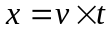 Equation (1)

We can then solve for radial distance from the target based on horizontal distance and altitude of flight using the Pythagorean Theorem.

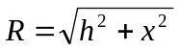 Equation (2)

This distance R is the furthest our UAV will be from the target during the jamming period. At this time, the signal will propagate over more distance, thus attenuating by the greatest amount. We can solve for the attenuation in decibels over this distance using the Free Space Path Loss (FSPL) equation. We use the highest frequency in our band for this calculation as it will suffer the most loss, where R is the distance, f is signal frequency, and c is speed of light.

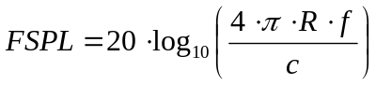 Equation (3)

Since we know that the radio transmits a 50 watt signal (17 dB), we are estimating a receiver sensitivity of -80 dBm. We need to jam the receiver with 5 dB more than its sensitivity, so we must transmit enough power so that -75 dBm reaches the target. Using that value and the calculated attenuation, we determine the required transmit power of our antenna array.

Our group then looks at the system when the UAV is directly over the center of the target area. This is when the distance from the jammer to the radio is at its minimum, meaning that the area being jammed will be at its smallest. We can use system geometry to determine the beam width angle required from our antenna array in both the x and y direction, respectively, where r is the radius of the target area and h is the altitude
.
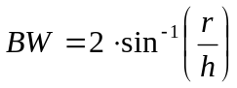 Equation (4)

Using the antenna beamwidth equation, we solve for the necessary spacing dimensions of our antenna array. Here, we must use the smallest wavelength signal as that signal will result in the smallest beamwidth. Since our beam pattern is an ellipse, our array will be a rectangle, and we must solve for the necessary dimensions in both the x and y directions. λ is the wavelength of the highest frequency signal and D represents a dimensional constraint of our array.

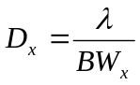 Equation (5)
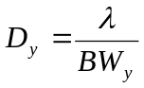 Equation (6)

The overall dimension D in the x and y directions controls the number of elements each respective direction. The spacing between each element, d_{x} or d_{y}, was specified by our team.
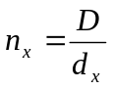 Equation (7)
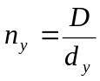 Equation (8)
The optimal spacing typically occurs when d_{x} or d_{y} is between λ/2 and λ. The spacing in each direction is optimized to obtain the minimum necessary elements while maintaining an appropriate beam pattern and antenna gain.

The antenna gain is calculated once the antenna array dimensions and components are known. The gain is a function of number of elements in the array, the element spacing, and the wavelength the antenna array is using during operation.
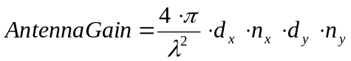 Equation (9)
After the antenna gain is calculated, we determine the power requirement needed in selecting a High Power Amplifier (HPA).
HPA Gain = Power at Receiver – Antenna Gain + FSPL Equation (10)
The beam profile of the jamming signal has the ability to become a tapered beam by adjusting the power going to the different elements. In this problem, we are using a uniform profile for the jamming signal beam. This means that each element of the antenna is receiving an equal amount of power.

We calculate the wave number, k, of the of the antenna pattern for a given wavelength using Equation (11).
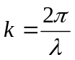 Equation (11)
The signal is calculated and plotted. The signal pattern can be expressed Equation (12). Here, ф is the steering angle, θ is the angle of propagation, m is the number of elements, d is the distance between each element, and k is the wave number.
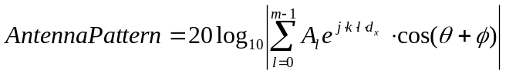 Equation (12)

The signal is then plotted for a variety of cases. The cases can be seen in Table (1).

Table (1) - Antenna Beam Pattern Cases
Case | Frequency (GHz) | Steering Angle
1 | 3.5 | 0º
2 | 4.65 | 0 º
3 | 5.8 | 0 º
4 | 3.5 | 45 º
5 | 4.65 | 45 º
6 | 5.8 | 45 º

In addition to these plots, two additional plots are included: a plot of antenna gain vs. frequency and beam width vs. frequency. The beam width plot shows that the beam width of the antenna will meet or exceed what is required at all frequencies in band.

The beam pattern plots show how power is distributed at different angles from the antenna array. The lobe with the highest amplitude is the main signal. The lobes surrounding the main signal are called side lobes or grating lobes. For the main signal to operate correctly the side lobes need to have a magnitude that is a minimum of 13 dB less than the amplitude of the main signal. This remains true for all six of our beam with plots. All of our plots can be seen in Appendix A – Performance Plots. The code used to perform the system calculations and to generate the plots is located in Appendix C – MATLAB Code.

Mechanical Analysis

The margins of safety (MS) for the mounting bolts of the antenna assembly are calculated assuming a load of 404lbf during an emergency landing. The maximum loading in the emergency landing scenario occurs in the front load case, creating a 9g load factor as seen in Equation (13).

Equation (13)
Using the screw yield stress in both shear and tension, it was possible to calculate the MS. This calculation assumes that the 6, stainless steel mounting bolts equally share the loading.

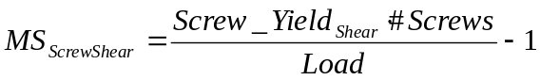 Equation (14)

 Equation (15)

The MS of both loading cases (shear and tension) result in a margin of safety greater than six. This implies that a single bolt can support the maximum load.

Our group then calculates the stresses on the antenna assembly during normal operation. The loads acting on the cover were calculated in order to correctly analyze it. The two main loads acting on the cover are the weight of the assembly (40lbf) and the drag force or pressure from the air during operation. The drag force is calculated using a drag coefficient (C_{d}) that is assumed based on the shape and material used to build the cover. The drag also depends on the density of the air (ρ, assumed to be dry air at 20ºC), the surface area (A), and the velocity (v, operational velocity = 44.44m/s) as seen in Equation (16).

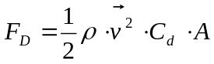 Equation (16)

In order to correctly apply the drag force to the antenna cover for analysis, the force is converted to a drag pressure (P_{d}) that was applied to the surfaces in contact with the air. Note that the trailing edges of the cover will not be in contact with the air due to boundary layer separation. The drag pressure is calculated as seen in Equation (17).
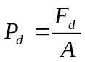 Equation (17)

The Pro-E model of the 6061-T6 aluminum antenna cover was imported into ANSYS Workbench in order to substantiate its design. The maximum displacement and maximum stress of the antenna cover is computed using the drag pressure and weight as its loading scenario

A MS for the Antenna Cover is determined using the maximum stress from the ANSYS analysis. The MS for the antenna cover is calculated using the yield stress of the aluminum and a safety factor of 1.5 (Standard for aircraft analysis). All other mechanical computations, including aircraft images, loading orientation, and stress and displacement results are found in Appendix B – Electrical/Mechanical Analysis.

Results

Results

The Predator UAV flies at a cruising speed of 160 kilometers per hour and altitude of 7500 meters. At the furthest point from the target, we need to transmit 81.56 dBW from our antenna array in order to provide enough power to jam a receiver. At the nearest point to the target, we must ensure that we jam an area 10 nautical miles wide and 2 kilometers deep. We found that at our altitude, we need a beam width of 101.99 degrees by 15.19 degrees.

To meet this requirement, our group found that an antenna array of 19.5 centimeters by 2.9 centimeters is sufficient. We selected element spacing in the x dimension of the λ/2 in order to increase power. In the y dimension, we selected a spacing of λ/4 to increase resolution. As a result, we have 2.586 centimeter spacing in the x dimension and 1.29 centimeter spacing in the y dimension. To obtain the correct antenna array size, we have a grid of 8 by 3 elements.

Based on our element spacing and array dimensions, we found our antenna to have a minimum gain of 22.75 dB in our frequency range. This leaves 58.8 dB of gain to be made up in the HPA array. Each of the 24 HPAs will then need to provide 2.45 dB of gain.

The system is comprised of an antenna cover that acts as a housing and mounting bracket for the system. The array of 24 antennas and 24 HPAs attach to a backplane or groundplane. Additionally there are other electrical components on the backplane that provide the appropriate resistances and voltages for the system. These components were approximated to weigh about 5lbs and consume about 50W. The basic components of the system can be seen as they are assembled in an exploded view in Appendix B – Electrical/Mechanical Analysis.

We selected components based on our antenna and HPA trade study, as seen in Appendix D – Trade Study. Through mechanical analysis, the following specifications were determined for our system:

Total System Power Consumption = 324.2W
Total System Weight = 20.4kg = 44.88lb
Max Von Mises Stress on Antenna Cover = 0.692 MPa
- Stress result of weight loading and drag for loading
Max Displacement of Antenna Cover during Loading = 1.59mm
Margin of Safety for Antenna Cover Stress = 265
Margin of Safety for Mounting Bolts in Shear = 10
Margin of Safety for Mounting Bolts in Tension = 8.4

System drawings and more detailed information is available in Appendix B – Electrical/Mechanical Analysis.

Plots of the beam pattern can be seen in Appendix A – Performance Plots. To provide an overall view of performance, we plotted the minimum frequency, the maximum frequency, and a midrange frequency at boresight and 45 degree steering angles. In all cases, the main lobe is wide enough to cover the target region and the side lobes are sufficiently suppressed. Other plots included in Appendix A include Antenna Gain vs. Frequency and Beam Width vs. Frequency. It is evident in these plots that the antenna provides sufficient gain across the frequency range and the beam width is adequate in both dimensions across the entire frequency range.

Recommandations

We have determined that a planar antenna array with 24 elements placed in a grid of 8 by 3 as described in our results section will meet or exceed all requirements for this mission. Team MCCCXXXVII recommends that the antenna array be developed as described immediately so that Operation SANTA can be executed successfully.

References

http://67.19.158.181/web/2.4ghz_6.5ghz_uwb_log_periodic_antenna.php

http://ams.aeroflex.com/ProductFiles/DataSheets/Amplifiers/PA0201803025ss.pdf

http://www.antennas.us/store/p/214-SL-5001-B357-Broadband-Omni-antenna-3-0-8-0-GHz-SMA-Female.html

http://www.astronwireless.com/product_details.aspx?id=145&cId=108

http://www.bnztech.com/datasheets/wideband/BZ0208LB1A.pdf

http://www.rfamplifiers.com/fibertelcomamps.html

Appendix

Appendix A – Performance Plots

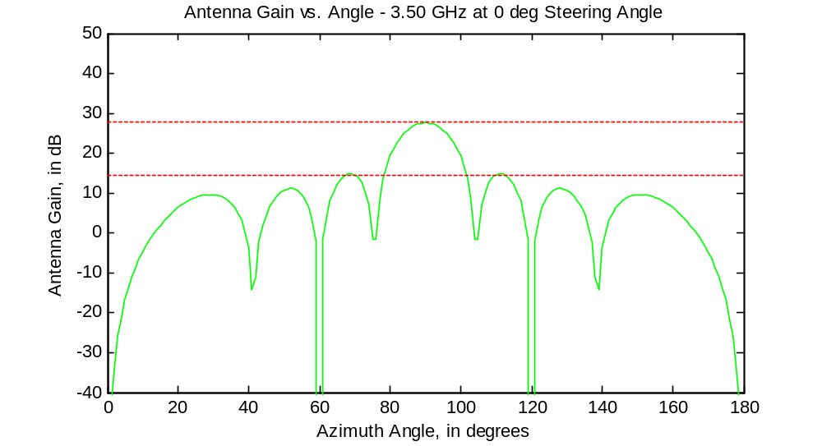

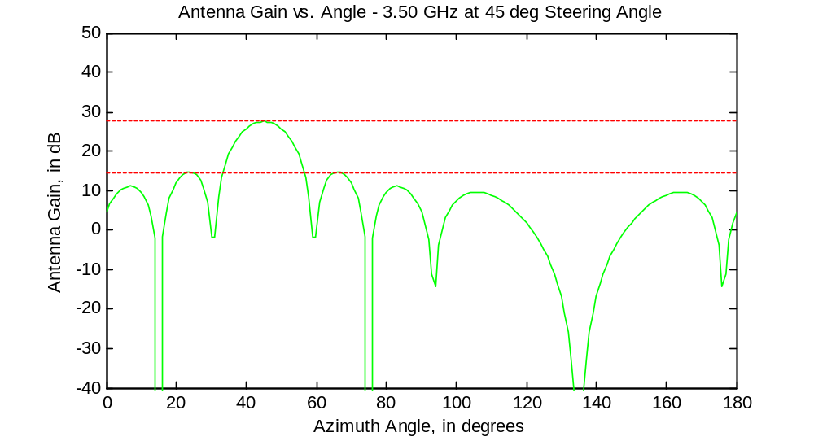

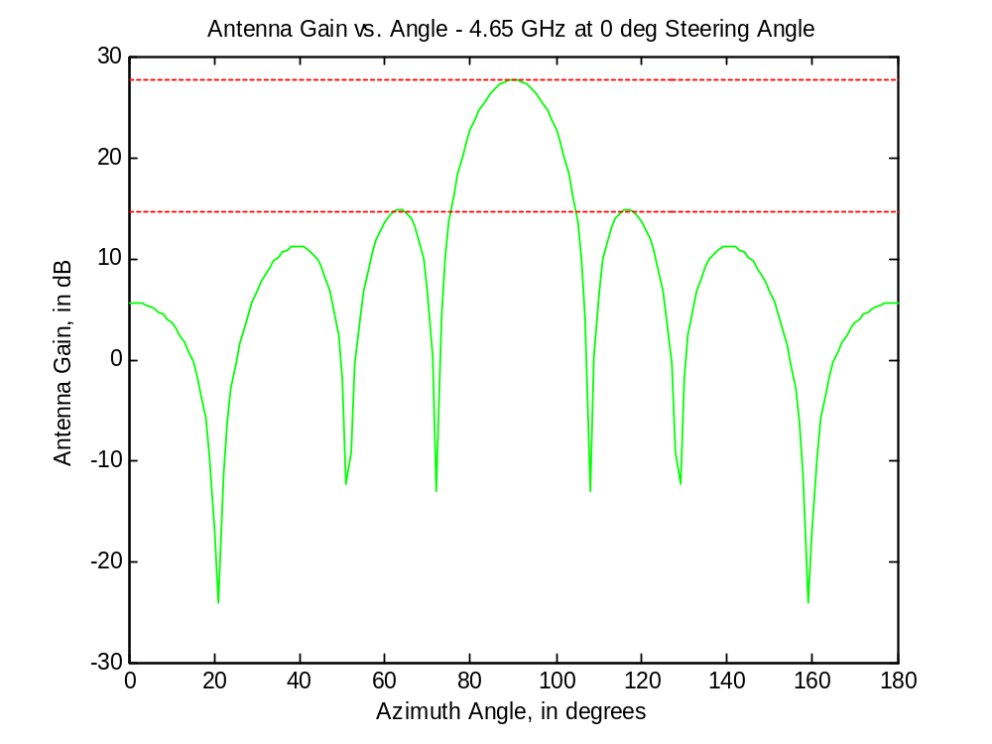

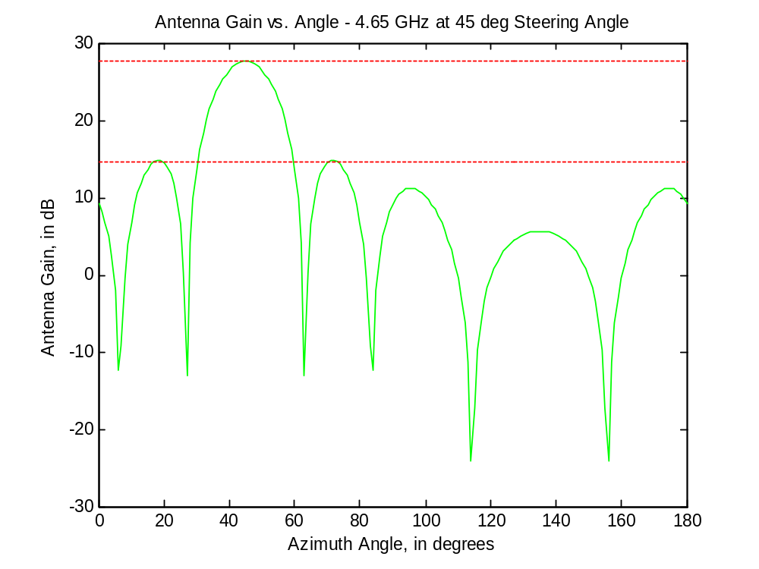

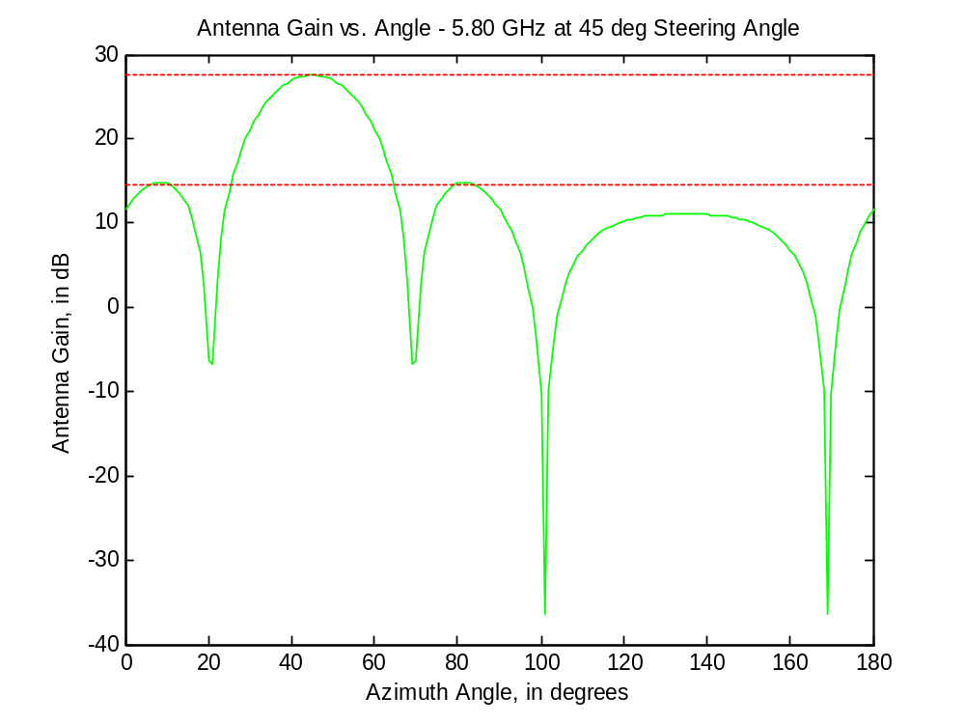
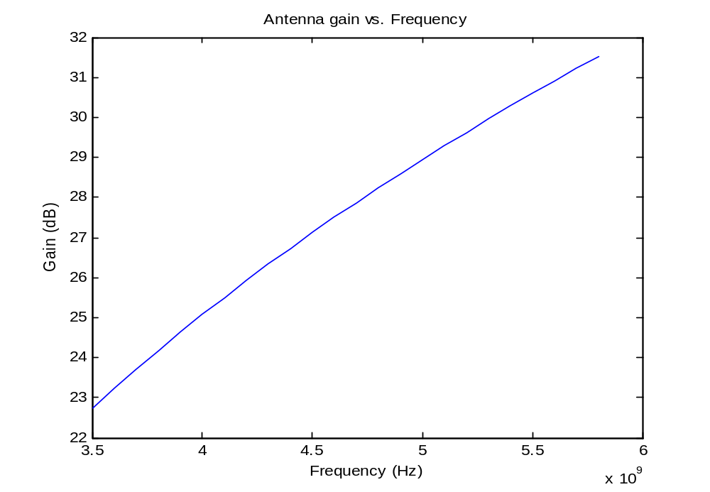

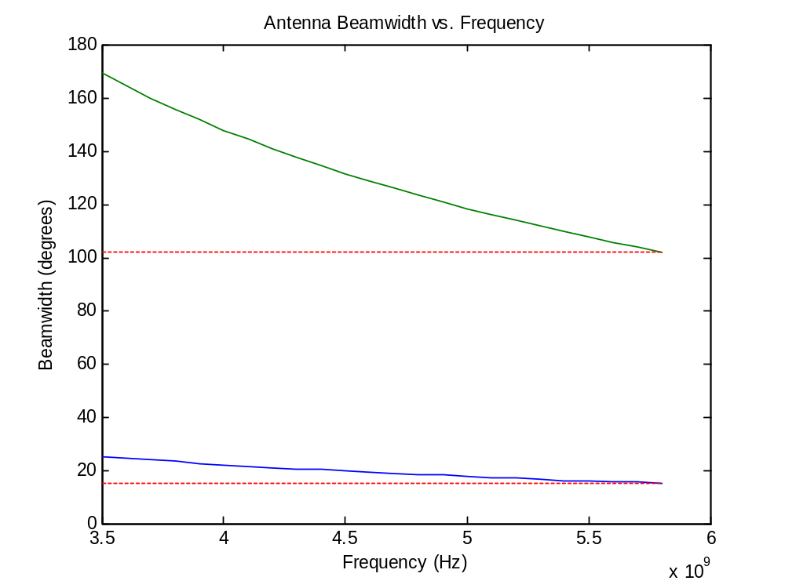

Appendix B – Electrical/Mechanical Analysis

Antenna Assembly Weights

Component | Weight (kg) | Qty | Total Weight (kg)
Antenna Cover | 4.845 | 1 | 4.845
Mounting Hardware | 1.4 | 1 | 1.4
Backplate Board | 0.59 | 1 | 0.59
Cables and Other Various Electrical Components | 4.845 | 1 | 4.845
Antenna | 0.227273 | 24 | 5.454545455
High Power Amplifier | 0.136364 | 24 | 3.272727273
 |  | TOTAL | 20.40727273

Antenna Assembly Power Consumption

Component | Power (W) | Qty | Total Power (W)
Antenna | 10 | 24 | 240
High Power Amplifier | 1.425 | 24 | 34.2
Other Electrical Components | 50 | 1 | 50
 |  | TOTAL | 324.2

Mechanical Assembly
ANTENNA ARRAY ASSEMBLY
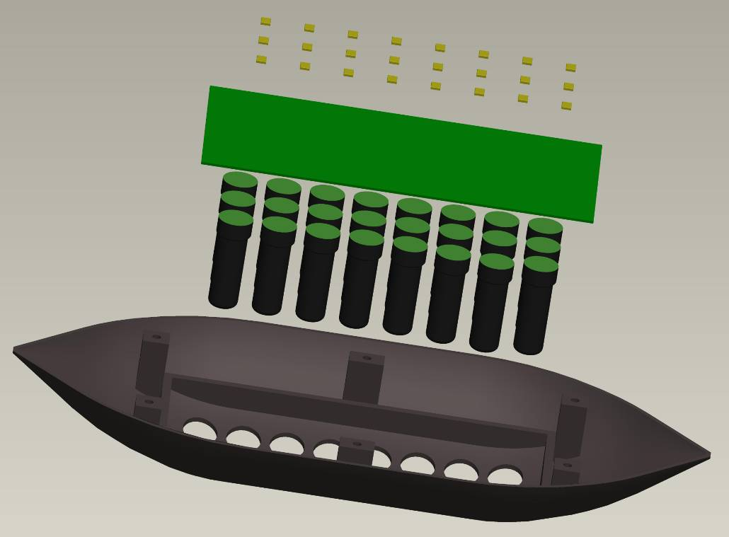
Antenna Cover
Antenna Elements
Ground Plane/ Board
High Power Amplifiers

ANTENNA ARRAY VIEW

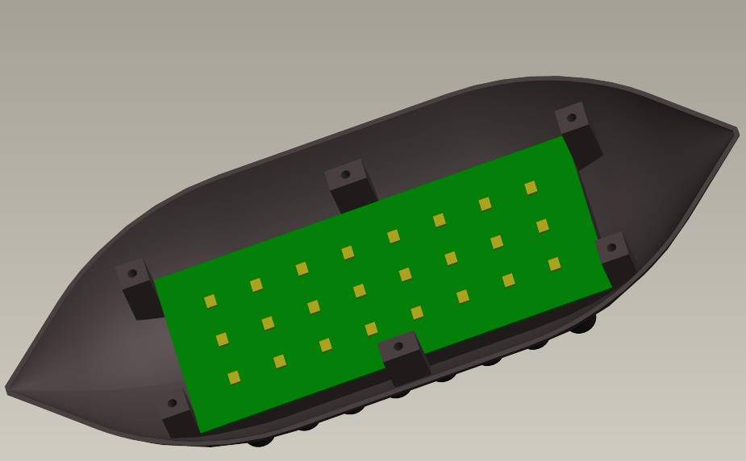

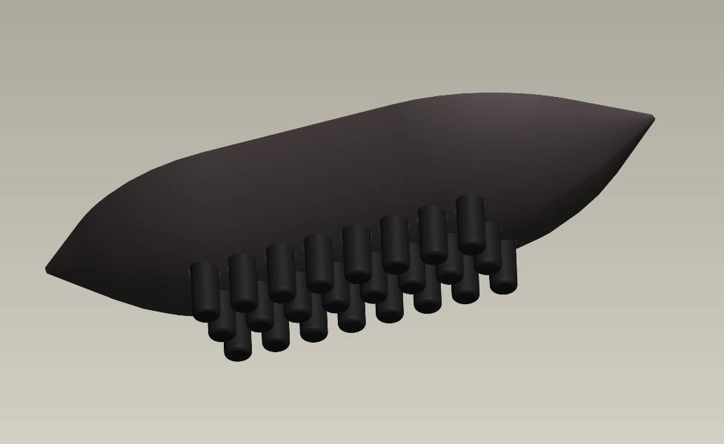

MQ-9 PREDATOR UAV WITH MOUNTED ANTENNA ARRAY
(BOTTOM VIEW)

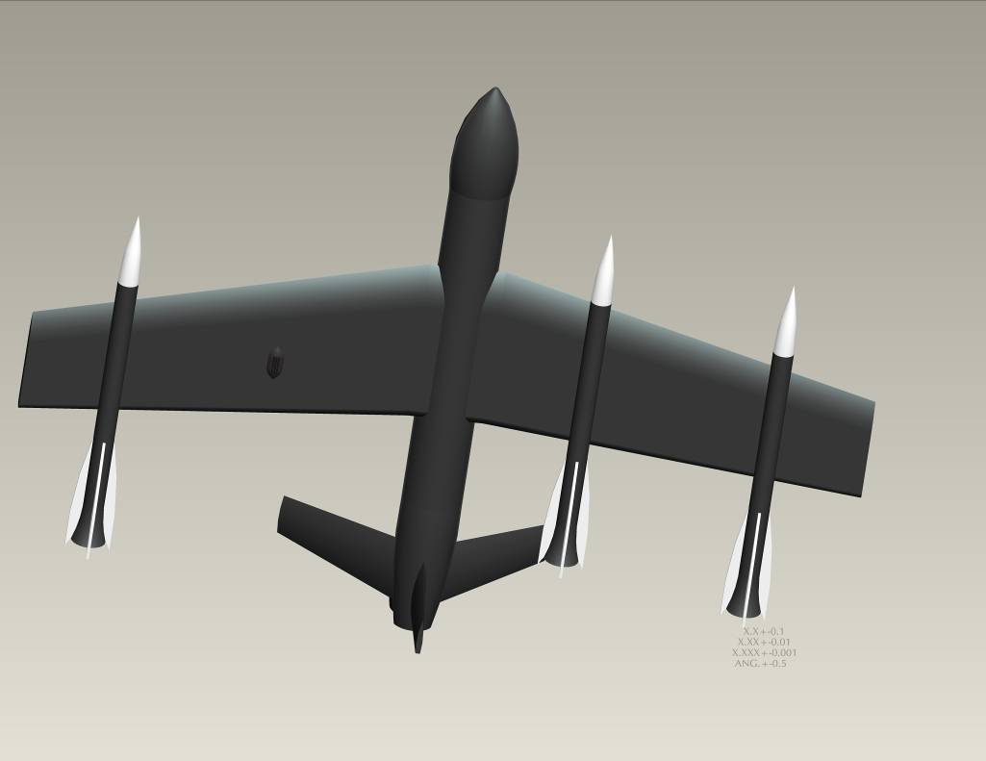

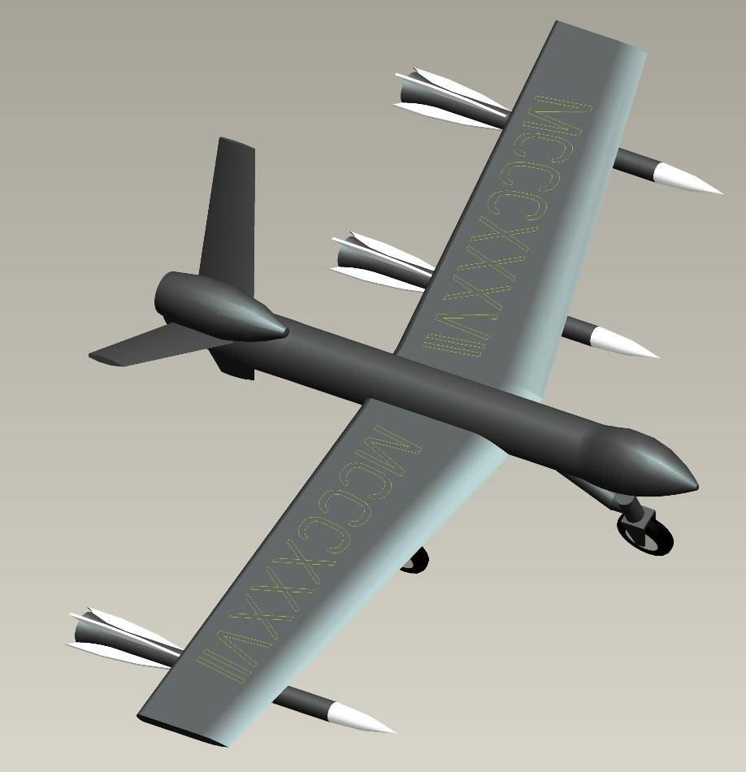

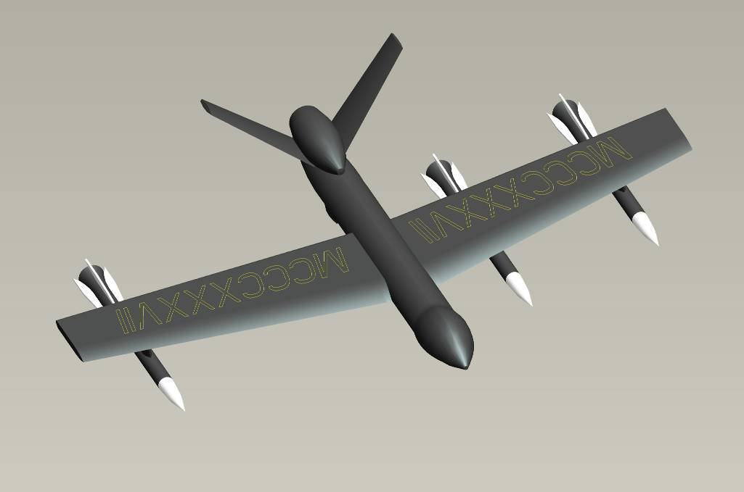

FRONT VIEW OF MQ9 WITH MOUNTED ANTENNA ARRAY

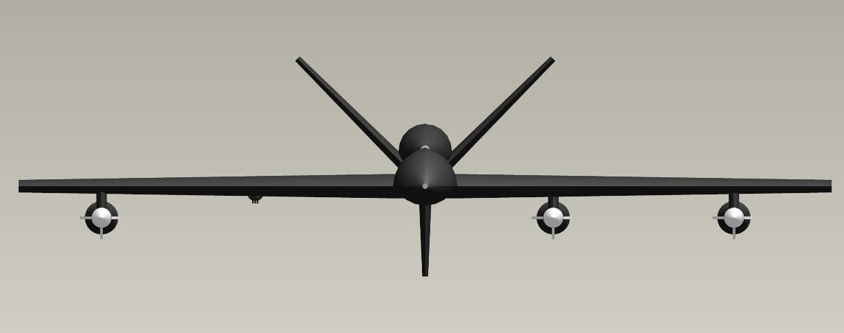
PLANAR ANTENNA ARRAY

Structural Substantiation of Antenna Assembly
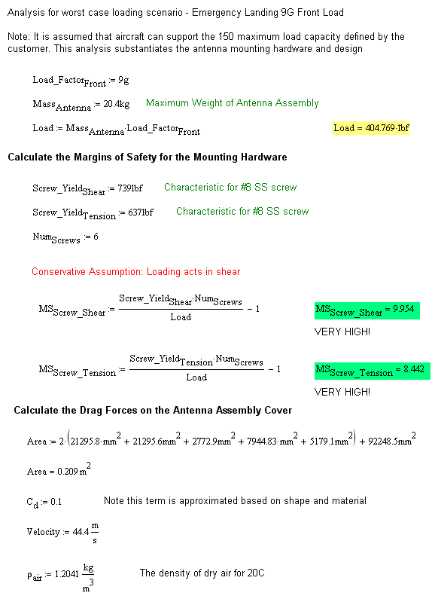

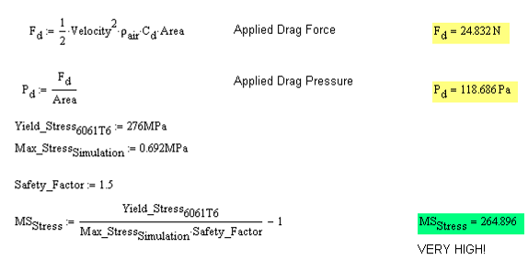

Stress Analysis on Antenna Assembly Cover
These values were used to calculate the MS_{stress} value for the cover.

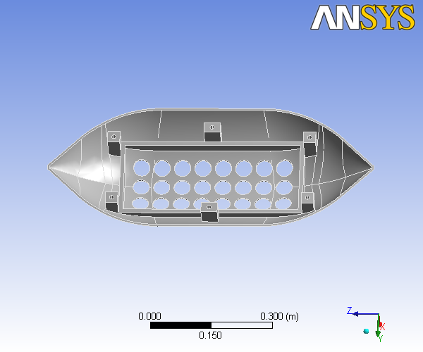

Mechanical Statistics and Tables

TABLE 1
Unit System | Metric (m, kg, N, °C, s, V, A)
Angle | Degrees
Rotational Velocity | rad/s

Geometry
TABLE 2
Model > Geometry
Object Name | Geometry
State | Fully Defined
Definition
Source | C:\Week5 TDC - UAV\ANTENNA_COVER.PRT.6
Type | ProEngineer
Length Unit | Millimeters
Element Control | Program Controlled
Display Style | Part Color
Bounding Box
Length X | 0.12605 m
Length Y | 0.3434 m
Length Z | 0.80176 m
Properties
Volume | 1.7945e-003 m³
Mass | 4.9709 kg
Statistics
Bodies | 1
Active Bodies | 1
Nodes | 12119
Elements | 5620
Preferences
Import Solid Bodies | Yes
Import Surface Bodies | No
Import Line Bodies | No
Parameter Processing | Yes
Personal Parameter Key | DS
CAD Attribute Transfer | No
Named Selection Processing | No
Material Properties Transfer | Yes
CAD Associativity | Yes
Import Coordinate Systems | No
Reader Save Part File | No
Import Using Instances | Yes
Do Smart Update | No
Attach File Via Temp File | No
Analysis Type | 3-D
Mixed Import Resolution | None
Enclosure and Symmetry Processing | Yes

TABLE 3
Model > Geometry > Parts
Object Name | ANTENNA_COVER
State | Meshed
Graphics Properties
Visible | Yes
Transparency | 1
Definition
Suppressed | No
Material | Aluminum Alloy
Stiffness Behavior | Flexible
Nonlinear Material Effects | Yes
Bounding Box
Length X | 0.12605 m
Length Y | 0.3434 m
Length Z | 0.80176 m
Properties
Volume | 1.7945e-003 m³
Mass | 4.9709 kg
Centroid X | 1.769e-003 m
Centroid Y | -2.5176e-005 m
Centroid Z | 2.2648e-005 m
Moment of Inertia Ip1 | 0.22784 kg·m²
Moment of Inertia Ip2 | 0.18831 kg·m²
Moment of Inertia Ip3 | 4.6929e-002 kg·m²
Statistics
Nodes | 12119
Elements | 5620

Mesh
TABLE 4
Model > Mesh
Object Name | Mesh
State | Solved
Defaults
Physics Preference | Mechanical
Relevance | 0
Advanced
Relevance Center | Coarse
Element Size | Default
Shape Checking | Standard Mechanical
Solid Element Midside Nodes | Program Controlled
Straight Sided Elements | No
Initial Size Seed | Active Assembly
Smoothing | Low
Transition | Fast
Statistics
Nodes | 12119
Elements | 5620

Static Structural
TABLE 5
Model > Analysis
Object Name | Static Structural
State | Fully Defined
Definition
Physics Type | Structural
Analysis Type | Static Structural
Options
Reference Temp | 22. °C
TABLE 6
Model > Static Structural > Analysis Settings
Object Name | Analysis Settings
State | Fully Defined
Step Controls
Number Of Steps | 1.
Current Step Number | 1.
Step End Time | 1. s
Auto Time Stepping | Program Controlled
Solver Controls
Solver Type | Program Controlled
Weak Springs | Program Controlled
Inertia Relief | Off
Nonlinear Controls
Force Convergence | Program Controlled
Moment Convergence | Program Controlled
Displacement Convergence | Program Controlled
Rotation Convergence | Program Controlled
Line Search | Program Controlled
Output Controls
Calculate Stress | Yes
Calculate Strain | Yes
Calculate Results At | All Time Points
Analysis Data Management
Solver Files Directory | C:\Week5 TDC - UAV\ANTENNA_COVER Simulation Files\Static Structural\
Future Analysis | None
Save ANSYS db | No
Delete Unneeded Files | Yes
Nonlinear Solution | No
TABLE 7
Model > Static Structural > Loads
Object Name | Fixed Support | Pressure | Force
State | Fully Defined
Scope
Scoping Method | Geometry Selection
Geometry | 1 Face | 11 Faces | 1 Face
Definition
Type | Fixed Support | Pressure | Force
Suppressed | No
Define By |  | Components
X Component |  | 0. Pa (ramped) | 200. N (ramped)
Y Component |  | 0. Pa (ramped) | 0. N (ramped)
Z Component |  | 118. Pa (ramped) | 0. N (ramped)

FIGURE 1
Model > Static Structural > Pressure
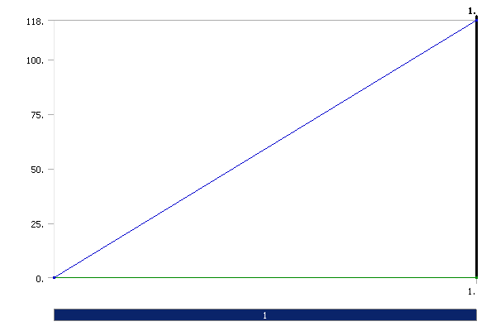
FIGURE 2
Model > Static Structural > Force
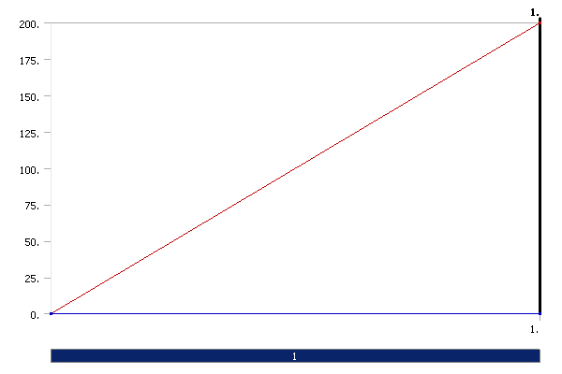

Solution
TABLE 8
Model > Static Structural > Solution
Object Name | Solution
State | Solved
Adaptive Mesh Refinement
Max Refinement Loops | 1.
Refinement Depth | 2.

TABLE 9
Model > Static Structural > Solution > Solution Information
Object Name | Solution Information
State | Solved
Solution Information
Solution Output | Solver Output
Newton-Raphson Residuals | 0
Update Interval | 2.5 s
Display Points | All

TABLE 10
Model > Static Structural > Solution > Results
Object Name | Equivalent Stress | Total Deformation
State | Solved
Scope
Geometry | All Bodies
Definition
Type | Equivalent (von-Mises) Stress | Total Deformation
Display Time | End Time
Results
Minimum | 232.23 Pa | 0. m
Maximum | 6.923e+005 Pa | 1.5871e-003 m
Information
Time | 1. s
Load Step | 1
Substep | 1
Iteration Number | 1

Material Data

Aluminum Alloy
TABLE 11
Aluminum Alloy > Constants
Structural
Young's Modulus | 2.76e+008 Pa
Poisson's Ratio | 0.33
Density | 2770. kg/m³
Thermal Expansion | 2.3e-005 1/°C
Tensile Yield Strength | 2.8e+008 Pa
Compressive Yield Strength | 2.8e+008 Pa
Tensile Ultimate Strength | 3.1e+008 Pa
Compressive Ultimate Strength | 0. Pa
Thermal
Specific Heat | 875. J/kg·°C
Electromagnetics
Relative Permeability | 1.
Resistivity | 5.7e-008 Ohm·m

FIGURE 3
Aluminum Alloy > Thermal Conductivity
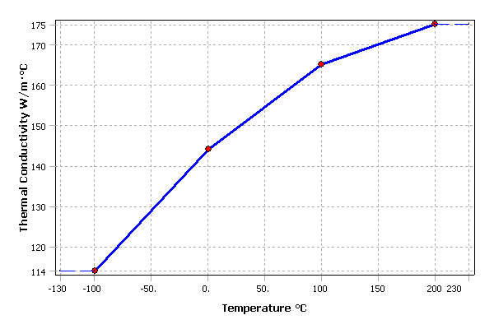
TABLE 12
Aluminum Alloy > Thermal Conductivity > Thermal Conductivity vs. Temperature

Temperature °C | Thermal Conductivity W/m·°C
-100. | 114.
0. | 144.
100. | 165.
200. | 175.

FIGURE 4
Aluminum Alloy > Alternating Stress
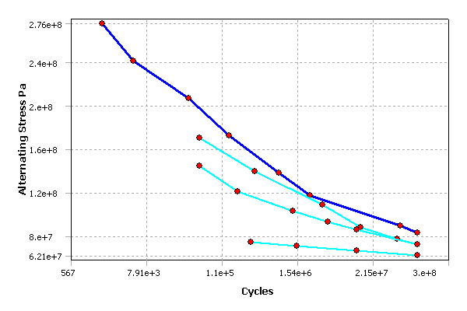
TABLE 13
Aluminum Alloy > Alternating Stress > Property Attributes
Interpolation | Semi-Log
Mean Curve Type | R-Ratio
TABLE 14
Aluminum Alloy > Alternating Stress > Alternating Stress Curve Data
Mean Value
-1.
-0.5
0.
0.5
TABLE 15
Aluminum Alloy > Alternating Stress > Alternating Stress vs. Cycles
Cycles | Alternating Stress Pa
1700. | 2.758e+008
5000. | 2.413e+008
34000 | 2.068e+008
1.4e+005 | 1.724e+008
8.e+005 | 1.379e+008
2.4e+006 | 1.172e+008
5.5e+007 | 8.963e+007
1.e+008 | 8.274e+007

Loading For ANSYS Analysis

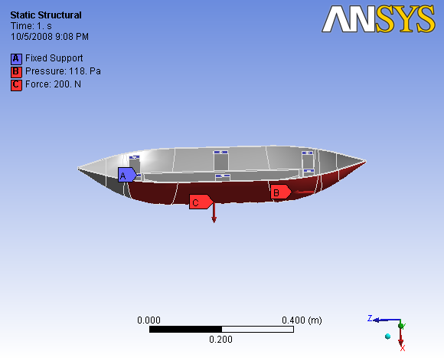

Displacement for ANSYS Analysis

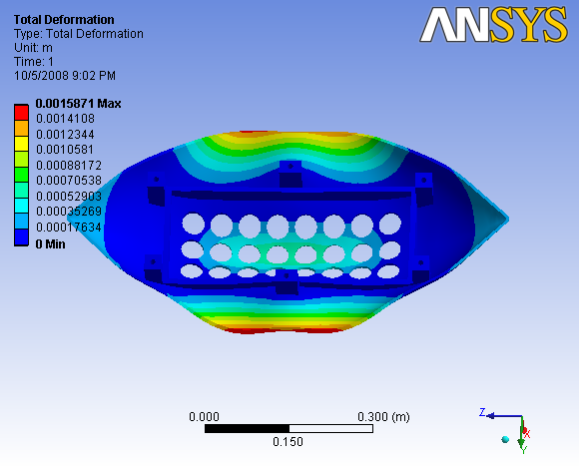

Stress for ANSYS Analysis

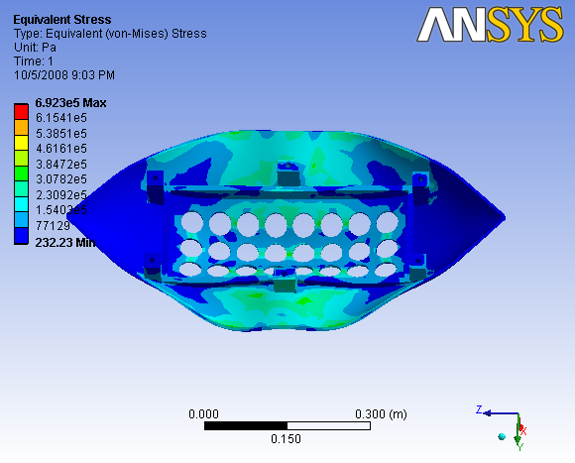

Appendix C – MATLAB Code

close all;
clear all;
%% Define Initial Parameters %%

fprintf('-INPUTS------------------------\n');

% These are the variables we can adjust:
v = 160000/3600; % Velocity in m/s - 160km/h
h = 7500; % Initial height (m) - cruising altitude
ele_wt = .5+.3; % Weight per element (lbs)
ele_pwr = 10+1.425; % Power per element (W)

fprintf('Velocity: %f m/s\n',v);
fprintf('Altitude: %f m\n',h);
fprintf('Weight per Element: %f lbs\n',ele_wt);
fprintf('Power per Element: %f W\n',ele_pwr);

% Define constants:
c = 3e8; % Speed of Light (m/s)
freq_l = 3.5e9; % Lower frequency bound of antenna bandwidth
freq_u = 5.8e9; % Upper frequency bound of antenna bandwidth
freq_m = (freq_l + freq_u)/2; % Middle frequency of antenna bandwidth

lambda_l = c / freq_l; % Wavelength at low freq
lambda_u = c / freq_u; % Wavelength at high freq
lambda_m = c / freq_m; % Wavelength at mid freq

dx = lambda_u/2; % Element Spacing (x)
dy = lambda_u/4; % Element Spacing (y)

%% Define parametric equations based on Initial Parameters %%

fprintf('-OUTPUTS-----------------------\n');

xi = v * 600; % X Position at time t=0 (600 seconds from target)
Ri = sqrt(h^2 + xi^2); % Radial distance from the start point to target
theta_Max = atan(xi/h); % Maximum sweep angle
fprintf('Maximum Sweep Angle: %f degrees\n',theta_Max*180/pi);

% Calculate necessary Beamwidth (BW) at boresight (t = 10 minutes)
Bwx = 2* atan(1000/h); % 1 km band
Bwy = 2* atan(9260/h); % 5 nmi wide
fprintf('Beamwidth: %f x %f degrees\n',Bwx*180/pi, Bwy*180/pi);

% Calculate dimensions of phased antenna array.
Dx = lambda_u / Bwx; % Dx = dx*nx
Dy = lambda_u / Bwy; % Dy = dy*ny
fprintf('Array Size: %f x %f meters\n',Dx,Dy);
fprintf('Element Spacing: %f x %f meters\n',dx,dy);

nx = ceil(Dx / dx); % # of elements in x direction based on dimensions
ny = ceil(Dy / dy); % # of elements in y direction based on dimensions
tot_ele = nx * ny; % Total # of elements in array.
fprintf('Elements: %i x %i = %i\n',nx,ny,tot_ele);

tot_wt = tot_ele * ele_wt; % Total weight of the antenna array.
fprintf('Weight of Elements: %f lbs\n',tot_wt);

tot_pwr = tot_ele * ele_pwr; % Total power of antenna array.
fprintf('Power Consumption: %f W\n',tot_pwr);

% Calculate the total power needed for transmission :
% dBW (Receiver) = dBW (Antenna Gain + HPA) - FreeSpacePathLoss
% ==> Need -85 = -55dBW to be seen at the enemy receiver.

% FSP = 20 * log((4*pi*Ri*freq_u)/c) ~~~ in dB
% ===> Ri = Furthest radial distance (at t = 0)

FSPL = 20 * log10((4*pi*Ri*freq_u)/c);

% Calculate required power given all specifications.
% -55 = dBW seen at receiver

Req_TPwr_dB = -55 + FSPL; % Required dB at trasmitter.
fprintf('Required Tx Power: %f dBW\n',Req_TPwr_dB);

Req_TPwr = 10^((Req_TPwr_dB)/10); % Calculate req. pwr in Watts (W)

ant_gain = 20*log10((4*pi*nx*dx*ny*dy)/(lambda_l^2)); % Gain of antenna array
fprintf('Gain of Antenna: %f dB\n',ant_gain);
hpa_gain = Req_TPwr_dB - ant_gain; % Total Required Amp Gain
fprintf('Total Gain of HPA: %f dB\n',hpa_gain);
fprintf('Single HPA Gain: %f dB\n',hpa_gain/tot_ele);

%% Graph #1 - Lowest Freq @ 0 deg

lambda = lambda_u;

Wtel = ones(1,ny); % weights in elevation
bu = zeros(1,nx); % voltage in dB given to each element
WndBu = 10.^(-0.05.*bu); % voltage in watts
k = 2*pi/lambda; % wave number
phi = 0; % steering angle
%G = 10000 + 30dB %input power

theta=0:pi/180:pi;
for l = 1:nx
Au(l,:) = sum(Wtel)*WndBu(l)*exp((j*k*l*dx).*(cos(theta+ phi)));
end

G = 1;
Au_log = 20*log10(abs(sum(Au)).*sqrt(G));

figure(1);
plot(theta*180/pi,real(Au_log),'g',...
0:180,ones(1,length(theta))*max(real(Au_log)),'r:',...
0:180,ones(1,length(theta))*max(real(Au_log))-13,'r:');
title('Antenna Gain vs. Angle - 5.80 GHz at 0 deg Steering Angle')
xlabel('Azimuth Angle, in degrees')
ylabel('Antenna Gain, in dB');

%% Graph #2 - Lowest Freq @ 45 deg

lambda = lambda_l;

Wtel = ones(1,ny); % weights in elevation
bu = zeros(1,nx); % voltage in dB given to each element
WndBu = 10.^(-0.05.*bu); % voltage in watts
k = 2*pi/lambda; % wave number
phi = deg2rad(45); % steering angle
%G = 10000 + 30dB %input power

theta=0:pi/180:pi;
for l = 1:nx
Au(l,:) = sum(Wtel)*WndBu(l)*exp((j*k*l*dx).*(cos(theta+ phi)));
end

G = 1;
Au_log = 20*log10(abs(sum(Au)).*sqrt(G));

figure(2);
plot(theta*180/pi,real(Au_log),'g',...
0:180,ones(1,length(theta))*max(real(Au_log)),'r:',...
0:180,ones(1,length(theta))*max(real(Au_log))-13,'r:');
title('Antenna Gain vs. Angle - 5.80 GHz at 45 deg Steering Angle')
xlabel('Azimuth Angle, in degrees')
ylabel('Antenna Gain, in dB');

%% Graph #3 - Middle Freq @ 0 deg

lambda = lambda_m;

Wtel = ones(1,ny); % weights in elevation
bu = zeros(1,nx); % voltage in dB given to each element
WndBu = 10.^(-0.05.*bu); % voltage in watts
k = 2*pi/lambda; % wave number
phi = deg2rad(0); % steering angle;
%G = 10000 + 30dB %input power

theta=0:pi/180:pi;
for l = 1:nx
Au(l,:) = sum(Wtel)*WndBu(l)*exp((j*k*l*dx).*(cos(theta+ phi)));
end

G = 1;
Au_log = 20*log10(abs(sum(Au)).*sqrt(G));

figure(3);
plot(theta*180/pi,real(Au_log),'g',...
0:180,ones(1,length(theta))*max(real(Au_log)),'r:',...
0:180,ones(1,length(theta))*max(real(Au_log))-13,'r:');
title('Antenna Gain vs. Angle - 4.65 GHz at 0 deg Steering Angle')
xlabel('Azimuth Angle, in degrees')
ylabel('Antenna Gain, in dB');

%% Graph #4 - Lower Freq @ 45 deg

lambda = lambda_m;

Wtel = ones(1,ny); % weights in elevation
bu = zeros(1,nx); % voltage in dB given to each element
WndBu = 10.^(-0.05.*bu); % voltage in watts
k = 2*pi/lambda; % wave number
phi = deg2rad(45);
%G = 10000 + 30dB %input power

theta=0:pi/180:pi;
for l = 1:nx
Au(l,:) = sum(Wtel)*WndBu(l)*exp((j*k*l*dx).*(cos(theta+ phi)));
end

G = 1;
Au_log = 20*log10(abs(sum(Au)).*sqrt(G));

figure(4);
plot(theta*180/pi,real(Au_log),'g',...
0:180,ones(1,length(theta))*max(real(Au_log)),'r:',...
0:180,ones(1,length(theta))*max(real(Au_log))-13,'r:');
title('Antenna Gain vs. Angle - 4.65 GHz at 45 deg Steering Angle')
xlabel('Azimuth Angle, in degrees')
ylabel('Antenna Gain, in dB');

%% Graph #5 - Highest Freq @ 0 deg

lambda = lambda_u;

Wtel = ones(1,ny); % weights in elevation
bu = zeros(1,nx); % voltage in dB given to each element
WndBu = 10.^(-0.05.*bu); % voltage in watts
k = 2*pi/lambda; % wave number
phi = deg2rad(0); % steering angle
%G = 10000 + 30dB %input power

theta=0:pi/180:pi;
for l = 1:nx
Au(l,:) = sum(Wtel)*WndBu(l)*exp((j*k*l*dx).*(cos(theta+ phi)));
end

G = 1;
Au_log = 20*log10(abs(sum(Au)).*sqrt(G));

figure(5);
plot(theta*180/pi,real(Au_log),'g',...
0:180,ones(1,length(theta))*max(real(Au_log)),'r:',...
0:180,ones(1,length(theta))*max(real(Au_log))-13,'r:');
title('Antenna Gain vs. Angle - 3.50 GHz at 0 deg Steering Angle')
xlabel('Azimuth Angle, in degrees')
ylabel('Antenna Gain, in dB');

%% Graph #6 - Highest Freq @ 45 deg

lambda = lambda_u;

Wtel = ones(1,ny); % weights in elevation
bu = zeros(1,nx); % voltage in dB given to each element
WndBu = 10.^(-0.05.*bu); % voltage in watts
k = 2*pi/lambda; % wave number
phi = deg2rad(45);
%G = 10000 + 30dB %input power

theta=0:pi/180:pi;
for l = 1:nx
Au(l,:) = sum(Wtel)*WndBu(l)*exp((j*k*l*dx).*(cos(theta+ phi)));
end

G = 1;
Au_log = 20*log10(abs(sum(Au)).*sqrt(G));

figure(6);
plot(theta*180/pi,real(Au_log),'g',...
0:180,ones(1,length(theta))*max(real(Au_log)),'r:',...
0:180,ones(1,length(theta))*max(real(Au_log))-13,'r:');
title('Antenna Gain vs. Angle - 3.50 GHz at 45 deg Steering Angle')
xlabel('Azimuth Angle, in degrees')
ylabel('Antenna Gain, in dB');

%% Antenna Gain vs Frequency %%

freqs = [3.5:.1:5.8]*10^9;
lambdas = c./freqs;
Gs = 20*log10(4*pi*nx*dx*ny*dy./lambdas.^2);

figure(7);
plot(freqs,Gs);
title('Antenna gain vs. Frequency');
xlabel('Frequency (Hz)');
ylabel('Gain (dB)');

%% Beamwidth vs Frequency %%

BWxs = (180/pi)*(lambdas./Dx);
BWys = (180/pi)*(lambdas./Dy);

figure(8);
plot(freqs,BWxs,freqs,Bwx*180/pi*ones(1,length(freqs)),'r:',...
freqs,BWys,freqs,Bwy*180/pi*ones(1,length(freqs)),'r:');
title('Antenna Beamwidth vs. Frequency');
xlabel('Frequency (Hz)');
ylabel('Beamwidth (degrees)');

fprintf('\n');

Appendix D – Trade Study

Antenna:

A broadband omni antenna made by Antennas.US was selected for our system. It was selected due to its low input power requirement and low weight requirement. The dimensions are small however; we will need to work with the manufacturer to reduce the packaging size of the antenna. A benefit of this antenna is that it does not require a ground plane.

HPA:

A wideband LNA made by B&Z Technologies was selected for our system. It was selected due to its low input power requirements and small size. The weight of the three HPA’s was unknown and therefore was not considered as a comparison factor. An additional interface mounting bracket and cable are available for purchase if necessary. It could help reduce the overall price of the delivered package if COTS mounting brackets are used. The mounting bracket would also be convenient in the lab environment during testing of our product.
ANTENNA ELEMENT TRADE STUDY TABLE

Manufacturer | Description | Bandwidth (GHz) | Input Power (W) | Length (m) | Width (m) | Height (m) | Weight (lbs) | Picture
Astron Wireless Technologies, Inc | UHF Multiband Single Discone Antenna | 2GHz - 6GHz | 200W | .0254 | .0254 | 0.3556 | .5 | 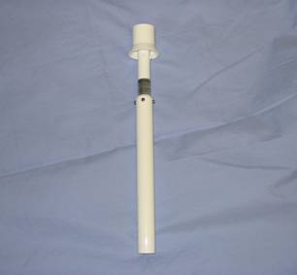
Hyperlink Technologies | Ultra Wide Band Enclosed Log Periodic Antenna | 2.3GHz - 6.5GHz | 50W | 0.0889 | 0.0332 | 0.162 | 1.3 | 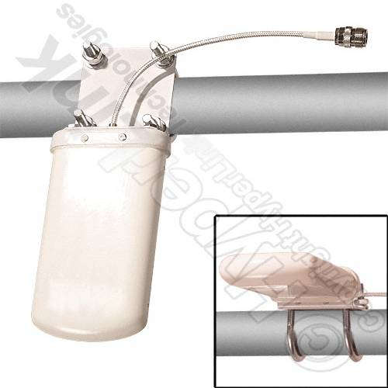
Antennas.US | Broadband Omni Antenna | 3.0GHz - 8.0GHz | 10 W | 0.04 | 0.04 | .11 | .5 | 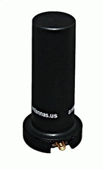

HIGH POWERED AMPLIFIER (HPA) ELEMENT TRADE STUDY TABLE

Manufacturer | Description | Bandwidth (GHz) | Input Power (W) | Length (m) | Width (m) | Height (m) | Weight (lbs) | Picture
Aeroflex | High Power Amplifier module | 2.0 - 18.0 | 36 | 0.027 | 0.0162 | 0.004 | 0.3* | 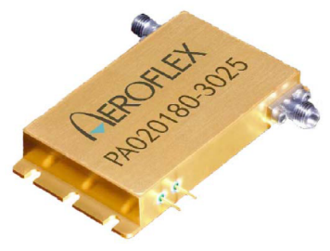
RF Amplifiers.Com | Ultra Wide Band Amplifier | 0.1 - 6.0 | --- | 0.02 | 0.015 | 0.015 | 0.3* | 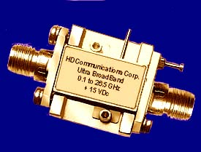
B&Z Technologies | Wideband LNA | 2.0 - 8.0 | 1.425 | 0.011 | 0.014 | 0.003 | 0.3* | 